AY Active Student Achievements & Recognition

Honor ‘Societies’ – ‘active membership’

Honors Program (Faculty Lead)
Millennium III Honors Program https://honors.wnmu.edu/?lang=en (New site in the works)
The WNMU Millennium III Honors Program serves students in all majors and minors with enriched courses and activities. To be a MII student they must apply and take honors courses for program membership, prior to graduation!

Cords are related to honors society membership:
Students, contact your chapter about cords

Major-focused Honors Societies at WNMU
- Alpha Phi Signa (Criminal Justice) https://behavioral.wnmu.edu/cjus/alpha-phi-sigma/
- Delta Mu Delta (Business Administration) https://sb.wnmu.edu/delta-mu-delta/
- Psi Chi (Psychology) https://behavioral.wnmu.edu

Other groups
- Student Government (ASWNMU) – Silver Cords https://aswnmu.wnmu.edu/?lang=en
- El Movimiento Estudiantil Chicano de Aztlan (MECHA)
- Native American Student Alliance, Dr. Fritz

- Education student may get a light blue cord from the College of Education with a Zipper pull WNMU logo

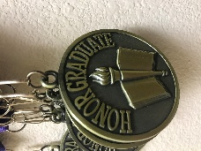
Merit Based Honors (GPA)

Academic Affairs- MEDALLION

Honors Breakfast event on campus; graduating with Honors (GPA) at WNMU

Baccalaureate degree candidates who have a cumulative grade-point average (GPA) of 3.5 or above are designated for honors at graduation as follows:
Cumulative G.P.A. Level in Latin
*3.90 or better Summa Cum Laude
*3.75 or better Magna Cum Laude
*3.50 or better Cum Laude
*They get a golden embossment of Honors on their diploma.

Masters Level ‘Honors’- Cumulative G.P.A. 4.0 - Provost Recognition; not a national standard, just gesture. Graduate Certificates (GC/CERT2) will also be recognized at 4.0 cumulative.

Student Affairs
(Published List, by Term) https://css.wnmu.edu/presidents-deans-list/

President's List (3.7-4.0 GPA)
To qualify for the President’s List, full-time students must earn at least a 3.7 grade point average and have at least 12 hours of credit for the term.

Dean's List (3.3-3.69 GPA)
To qualify for the Dean’s List, full-time students must earn at least a 3.3 grade point average and have at least 12 credit hours for the term.

WNMU Bookstore

Caps & Gowns:
The WNMU Campus bookstore provides the caps, gowns, and tassels
–There is no charge for the cap and gown, as those are included in your student fees.

- $ Shipping: If you need shipping, please call the store for payment and to confirm your mailing address. Shipping cost- Standard 5-7 days is $9.99

Manager: (575) 538-6381 0341mgr@follett.com

Item for purchase:
https://www.bkstr.com/westernnewmexicostore/shop/graduation
Stoles: First Generation Graduate, Nationality, Military, etc. Announcement through Jostens
Zipper Pull - 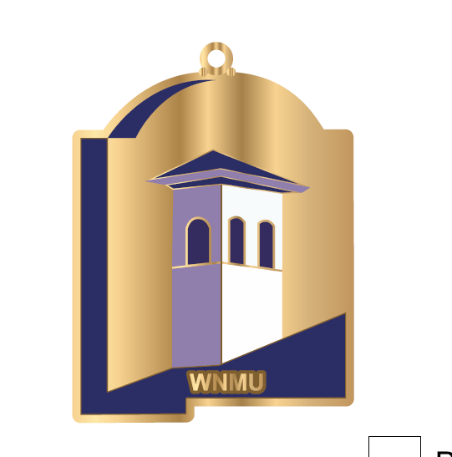

WNMU Stole – 